Option B: Task-3

Firstly, I move the downloaded financial dataframe and the NaN data process code from the processData function in task 2 into 2 separate function call downloadData() and processNANs(). We can re-use them by calling them in the processData function.

Candlestick Chart Function

The task requires the ability to set nnn as the number of trading days per stick, so the function should accept both a data frame and an nnn integer, with a default value of 1 if nnn is not provided.

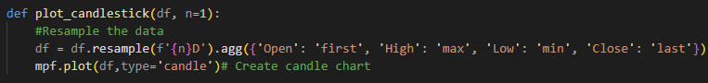

Boxplot Chart Function

The task require passing n as the rolling window size, so the function parameters include a dataframe, n for the window size, and a list of columns to display.

The rolling data is calculated for the dataframe by looping through each column and applying the rolling() method with n. A boxplot is generated using the pyplot subplots() method, with NaNs dropped from the rolling data. The plot's title is set, and the plot is displayed using pyplot.

Due to the volume column's significantly larger values making other columns appear invisible, I added the option to select which columns to display, allowing visibility by excluding the volume column.